*Process MeNtOR 3.0*

**Global Statistics Visualization Tool**

Requirements Model

|  |  |
| --- | --- |
| Version: | 2.0 |
| Print Date: |  |
| Release Date: | 2021/03/01 |
| Release State: |  |
| Approval State: |  |
| Approved by: |  |
| Prepared by: |  |
| Reviewed by: |  |
| Path Name: |  |
| File Name: | GSVT-SRS v2.0.docx |
| Document No: |  |

**Document Change Control**

|  |  |  |  |
| --- | --- | --- | --- |
| **Version** | **Date** | **Authors** | **Summary of Changes** |
| 1.0 | 2021/2/13 | Yifei Zhang | Initial write - Domain Model |
| 1.0 | 2021/2/13 | Zhen Yang | Use case descriptions 1-4 |
| 1.0 | 2021/2/13 | Ziqin Shang | Use case descriptions 5-8 |
| 1.0 | 2021/2/13 | Yumeng Chen | Introduction & Actors |
| 1.0 | 2021/2/14 | Yifei Zhang | Add Gantt Chart |
| 1.0 | 2021/2/14 | Yumeng Chen | Project Backlog |
| 2.0 | 2021/02/28 | Yifei Zhang | Test driven development |
| 2.0 | 2021/02/28 | Yifei Zhang | Update domain model and Gantt Chart |
| 2.0 | 2021/2/27 | Zhen Yang | Activity & Sequence diagrams(1-4) |
| 2.0 | 2021/2/28 | Zhen Yang | Revise of use case diagrams and description based on given feedback(1-4) |
| 2.0 | 2021/2/27 | Yumeng Chen | Non-Functional Requirements, Activities Plan |
| 2.0 | 2021/3/1 | Ziqin Shang | Activity & Sequence diagrams(5-8) |
| 2.0 | 2021/3/1 | Ziqin Shang | Revise of use case diagrams and description based on given feedback(5-8) |

**Document Sign-Off**

|  |  |  |
| --- | --- | --- |
| **Name (Position)** | **Initials** | **Date** |
|  |  |  |
|  |  |  |
|  |  |  |
|  |  |  |

**Contents**

**1** **Introduction 5**

1.1 Purpose 5

1.2 Overview 5

1.3 References 5

**2** **Business Scenario Model 6**

2.1 Actors 6

2.1.1 Overview 6

2.1.2 Actor Diagram 6

2.1.3 Actor Definitions 7

2.2 Use Case Descriptions 11

2.3 Use Case Diagrams 23

**3** **Domain Model 26**

3.1 Domain Model Class Diagram 26

3.2 Domain Model Class Definitions 26

**4** **Sequence and Activity Diagrams 28**

4.1 Sequencing Diagrams 28

4.2 Activity Diagrams 28

**5** **Non-Functional Requirements Specification 28**

5.1 Overview 28

5.2 Enabling Technologies 28

5.2.1 Target Hardware & Hardware Interfaces 29

5.2.2 Target Development Environment 29

5.2.3 System Interfaces 29

5.3 Capacity Planning 29

5.3.1 Permanent Storage 29

5.4 Network 29

5.5 Workstations 29

5.6 Operational Parameters 30

5.6.1 Useability 30

5.6.2 Reliability 30

5.6.3 Maintainability 30

5.6.4 Portability 30

**6** **Activities Plan 31**

6.1 Gantt Chart 31

6.2 Project Backlog and Sprint Backlog 31

6.3 Group Meeting Logs 32

**7** **Test Driven Development 33**

**8** **Domain Dictionary (optional and as required) 33**

8.1 Terms and Abbreviations 33

# Introduction

## Purpose

This document details the requirements the system <Data Analysis & Retrieval System>, based on the World Bank's environmental and health data, provides users with various data analysis and data display functions. Through the system, users could understand data more clearly.

## Overview

The aim of the project is to implement a friendly Data Analysis & Retrieval System which allows the user to retrieve and analyze the environment and health data from the World Bank's data repository, then display them with different types of graphs and textual output.

The login system connects the user database which ensures that only people with permissions could access this system.

The system is connected with the World Bank's data repository and extracts specific data into the system according to the user's choice.

The User Interface(UI) could select, analyze, and display data through a variety of conditions. Including more than six different types of analysts (Mortality at birth, Mortality at birth vs Health Expenses per 1000 people, Mortality at birth vs Health Expenses per 1000 people vs. Hospital Beds per 1,000 people, Mortality at birth vs GDP, Percentage of Unemployment vs GDP, and Percentage of Unemployment, etc.), five different countries, different start and end years, add or remove 5 different visualization graphs (Pie Chart, Line Chart, Bar Chart, Scatter Chart, Report), each year's textual summary.

Through this high degree of freedom Data Analysis & Retrieval System, users can learn about the environment and health data.

## References

Word Bank: https://datahelpdesk.worldbank.org/knowledgebase/articles/889392- about-the-indicators-apidocumentation.

Eclipse: http://www.eclipse.org/downloads/index.php

UMLet: https://www.umlet.com/

MS-Visio : https://support.microsoft.com/en-us/office/uml- diagrams-in-visio- ca4e3ae9-d413- 4c94-8a7a-38dac30cbed6?ui=en-us&rs=en-us&ad=us

ObjectAid: https://www.objectaid.com/home

Maven: https://maven.apache.org/

# Business Scenario Model

## Actors

### Overview

The actors in our system include end-users of software, administrators, and the database. The end-user actors exist in an environment that allows interaction with this Data Analysis & Retrieval System, and they could use the full software to obtain the information. Administrator actors have full access(read, write and execute permissions) to the Login system and Analysis system. The database includes the world bank database and user login database. The world bank database is to obtain the data that will be displayed and analyzed. The user login database is to store and check the users and to make sure the authorized user could enter the system.

### Actor Diagram

The figure below represents the actors in our system. Based on their interactions with the system, the actors are characterized into three general groups: a) Users, b) Database and c) Administrators. As demonstrated in the diagram, the database is a generalization of both the world bank database and login database. The Administrator is a generalization of both Registry System Administrator and Analysis method Administrator. (Please see next page for diagram).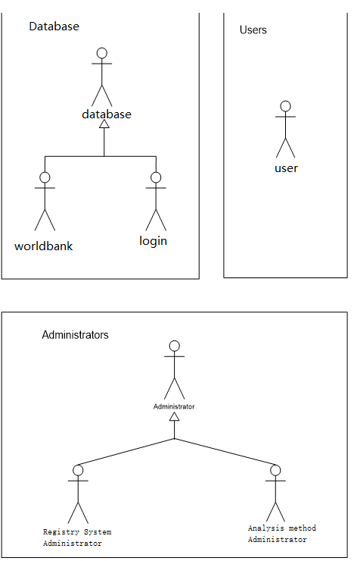

### Actor Definitions

### *User*

|  |  |
| --- | --- |
| **Description** | The User is a human actor that interacts with the system primarily through the Data Analysis & Retrieval System. Any person that uses this system is considered a User. The roles of this actor in the context of the system include login the system and request retrieving, analyses, and display the data. |
| **Aliases** | None |
| **Inherits** | None |
| **Actor Type** | Active Actor |
| **Contact Person** |  |
| **Contact Details** |  |

### *Database*

|  |  |
| --- | --- |
| **Description** | The Database is an external agent that is invoked through the system. Invoking a database executes the actions and returns the data back to the system. |
| **Aliases** | None. |
| **Inherits** | None. |
| **Actor Type** | Passive Actor |
| **Contact Person** |  |
| **Contact Details** |  |

### *World Bank Database*

|  |  |
| --- | --- |
| **Description** | The World Bank Database is an external agent that is invoked through the system. Extract database data based on the user's request and returns the data back to the system. |
| **Aliases** | None |
| **Inherits** | Database |
| **Actor Type** | Passive Actor |
| **Contact Person** |  |
| **Contact Details** |  |

### *Login Database*

|  |  |
| --- | --- |
| **Description** | The Login Database is an external agent that is invoked through the system. Extract database data based on the user's request and return the data back to the system and check the username & password. |
| **Aliases** | None |
| **Inherits** | Database |
| **Actor Type** | Passive Actor |
| **Contact Person** |  |
| **Contact Details** |  |

### *Administrator*

|  |  |
| --- | --- |
| **Description** | The administrator is a human actor who is in charge of a certain part of the system . His roles include the smooth operation, maintenance and updating of the system. |
| **Aliases** | None |
| **Inherits** | None |
| **Actor Type** | Active Actor |
| **Contact Person** |  |
| **Contact Details** |  |

### 

### *Registry System Administrator*

|  |  |
| --- | --- |
| **Description** | The Registry System administrator is a human actor who is in charge of the Registry System. His roles include the smooth operation, maintenance and updating of the server which consists of all the registered issues. |
| **Aliases** | None |
| **Inherits** | Administrator |
| **Actor Type** | Active Actor |
| **Contact Person** |  |
| **Contact Details** |  |

### *Analysis Method Administrator*

|  |  |
| --- | --- |
| **Description** | The Analysis Method administrator is a human actor who is in charge of the Analysis. His roles include the smooth operation, maintenance, and updating of the analysis algorithm and the database link which consists of all the data analysis issues. |
| **Aliases** | None |
| **Inherits** | Administrator |
| **Actor Type** | Active Actor |
| **Contact Person** |  |
| **Contact Details** |  |

## Use Case Descriptions

**UC1.**

|  |  |
| --- | --- |
| **Name** | The user logs into the system |
| **Goal in Context** | A user login interface that compares the combination of account names and passwords entered by the user with the combination in the database, terminates the application when the combination does not match, displays the main UI when the combination matches. |
| **Primary Actor** | User |
| **Secondary Actors** | Login database |
| **Preconditions** | The combinations of usernames and passwords already saved in the login database.  The combinations can be correctly compared with the combinations saved in the login database.  The login system can connect to the main UI. |
| **Trigger** | The user starts the system and input their username and password. |
| **Scenario Text** | Correct combinations:  1. The user starts the system.  2. The user enters the account name.  3. The user enters the password.  4. The user clicks the “Submit!” button.  5. The user sees the main UI. |
| **Alternative Scenario Courses** | Wrong combinations:  1. The user starts the system.  2. The user enters the account name.  3. The user enters the password.  4. The user clicks the “Submit!” button.  5. The system terminates. |
| **Constraints** | None. |
| **Questions** | If the system has been terminated, does the system need to ask the user to re-enter the username & password?  How many times does the system allow the user to re-enter? |

**UC2.**

|  |  |
| --- | --- |
| **Name** | Selecting the analysis type |
| **Goal in Context** | According to the user's requirements, the viewer remains intact or empty the viewer. |
| **Primary Actor** | User |
| **Secondary Actors** | None |
| **Preconditions** | The user has successfully logged in to the system.  The main UI has successfully shown to the user.  The user has selected the country which he/she likes to fetch. |
| **Trigger** | The user clicks the drop-down menu and chooses one analysis type. |
| **Scenario Text** | The user choose the different analysis type:  1. The user clicks the “↓” button in the bottom right of the main UI (left beside the “Recalculate” button) to choose the analysis type.  2. The user clicks one of the analysis types.  3. The chosen analysis type displays on the viewer. |
| **Alternative Scenario Courses** | The user choose the same analysis type:  1. The user clicks the “↓” button in the bottom right of the main UI (left beside the “Recalculate” button) to choose the analysis type.  2. The user clicks one of the analysis types.  3. The viewer remains intact. |
| **Constraints** | None. |
| **Questions** | None. |

**UC3.**

|  |  |
| --- | --- |
| **Name** | Selecting a country to fetch and visualize data |
| **Goal in Context** | According to the user's requirements, check whether the country selected by the user is available for data analysis. If yes, the data fetching can proceed,notify the user otherwise. |
| **Primary Actor** | User |
| **Secondary Actors** | Database |
| **Preconditions** | The user has successfully logged in to the system.  The main UI has successfully shown to the user.  The system successfully connects to the Database. |
| **Trigger** | The user clicks the drop-down menu and chooses one country. |
| **Scenario Text** | The chosen country is available for data analysis:  1. The user clicks the “↓” button in the middle top of the interface to choose the country.  2. The user clicks one of the countries.  3. Data fetching proceeds. |
| **Alternative Scenario Courses** | The chosen country is not available for data analysis:  1. The user clicks the “↓” button in the middle top of the interface to choose the country.  2. The user clicks one of the countries.  3. A message is displayed that the data analysis for the chosen country is not available. |
| **Constraints** | None. |
| **Questions** | After informing the user that the chosen country is not available to analyze data, does the system also need to prompt the user to re-choose the country? |

**UC4.**

|  |  |
| --- | --- |
| **Name** | Selecting the years for which the analysis type is to be performed |
| **Goal in Context** | According to the user's requirements, check whether the chosen years are valid. If yes, data fetching proceeds, notify the user and ask the user to re-enter otherwise. |
| **Primary Actor** | User |
| **Secondary Actors** | Database. |
| **Preconditions** | The user has successfully logged in to the system.  The main UI has successfully shown to the user.  The user has selected the analysis type which he/she likes to fetch. |
| **Trigger** | The user clicks the drop-down menu and chooses the years |
| **Scenario Text** | The years chosen by the user are valid:  1. The user clicks the “↓” button after “From” to choose the starting year.  2. The user clicks the “↓” button after “To” to choose the ending year.  3. Data fetching proceeds. |
| **Alternative Scenario Courses** | The years chosen by the user are not valid:  1. The user clicks the “↓” button after “From” to choose the starting year.  2. The user clicks the “↓” button after “To” to choose the ending year.  3. A message is displayed that the selected year is not valid, and prompts the user to select different years. |
| **Constraints** | None. |
| **Questions** | What if the chosen ending year is before the starting year, will it be treated as a non-valid year? |

**UC5.**

|  |  |
| --- | --- |
| **Name** | Adding the visualization graphs to display the obtained/computed data |
| **Description** | In this scenario, the user selects the visualization graph type to be performed and adds it to the main user interface, the program checks the compatibility of the graph and populates the error message if the viewer is not compatible. If the viewer is compatible, populate the desired graph. |
| **Primary actor** | User |
| **Secondary actors** | None |
| **Preconditions** | 1. The analysis type to be performed must be selected by the user  2. The country to be fetched and visualized must be selected by the user  3. The years for which the data to be fetched must be selected by the user  4. The World Bank Database must be on and functioning |
| **Trigger** | The view type is selected from the “Available Views” drop-down menu and the “+” button is pressed |
| **Scenario text** | 1. The user selects the view type and presses add button  2. Check for the compatibility of the visualization graphs  2.1. Populate error message if the criteria are not met  3. Populate graphs based on retrieved data and view type |
| **Alternative scenario courses** | None |
| **Constraints** | None |
| **Questions** | None |

**UC6.**

|  |  |
| --- | --- |
| **Name** | Removing the visualization graphs |
| **Description** | In this scenario, the user selects the visualization graph type to be removed, the program checks if the graph exists, then the program removes the existing graph. |
| **Primary actor** | User |
| **Secondary actors** | None |
| **Preconditions** | 1. The graph view type to be removed must be selected by the user |
| **Trigger** | The view type is selected from the “Available Views” drop-down menu and the “-” button is pressed |
| **Scenario text** | 1. The user selects the view type and presses remove button  2. Check for the existence of the visualization graphs  2.1. Populate error message if the criteria are not met  3. Remove graph from the interface |
| **Alternative scenario courses** | None |
| **Constraints** | None |
| **Questions** | None |

**UC7.**

|  |  |
| --- | --- |
| **Name** | Performing the analysis |
| **Description** | In this scenario, after the user specifies the country, the type of analysis, the years and the viewers, the user initiates the analysis by pressing the “Recalculate” button, the program then fetches all data required for performing the analysis, and compute the analysis result with these data if needed. |
| **Primary actor** | User |
| **Secondary actors** | World Bank Database |
| **Preconditions** | 1. The analysis type to be performed must be selected by the user  2. The country to be fetched and visualized must be selected by the user  3. The years for which the data to be fetched must be selected by the user  4. The viewer type must be selected by the user  5. The World Bank Database must be on and functioning |
| **Trigger** | The “Recalculate” button is pressed |
| **Scenario text** | 1. The user presses the “Recalculate” button  2. Identify the required data  3. Retrieve the required data from database  3.1. Populate error message if the data is not available  4. Compute the analysis result with fetched data  5. Populate result object |
| **Alternative scenario courses** | None |
| **Constraints** | None |
| **Questions** | None |

**UC8.**

|  |  |
| --- | --- |
| **Name** | Displaying the results |
| **Description** | In this scenario, after the system computes the analysis result and populated result object, the system then renders the results on the selected viewers, the system will decide how many series of data to be added to the selected viewers based on the analysis type. |
| **Primary actor** | User |
| **Secondary actors** | None |
| **Preconditions** | 1. The analysis result must be successfully computed  2. Result object must be successfully populated |
| **Trigger** | The result object is populated |
| **Scenario text** | 1. From the populated object, determine how many series of data to be added to the selected viewers based on the analysis type  2. Display the analysis result on the visualization graph |
| **Alternative scenario courses** | None |
| **Constraints** | None |
| **Questions** | None |

## 2.3 Use Case Diagrams

This section presents the business scenarios of the subject area in a graphical form.

**UC1**.

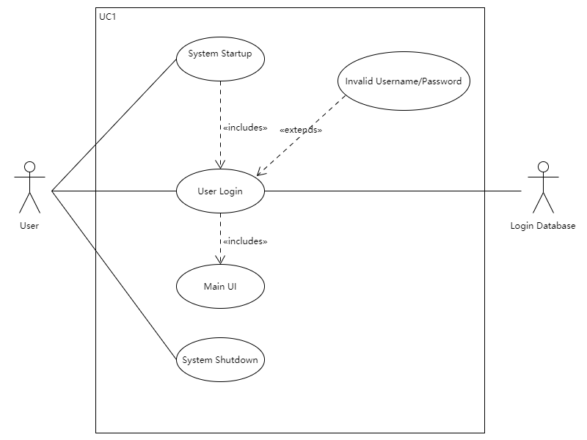

**UC2.**

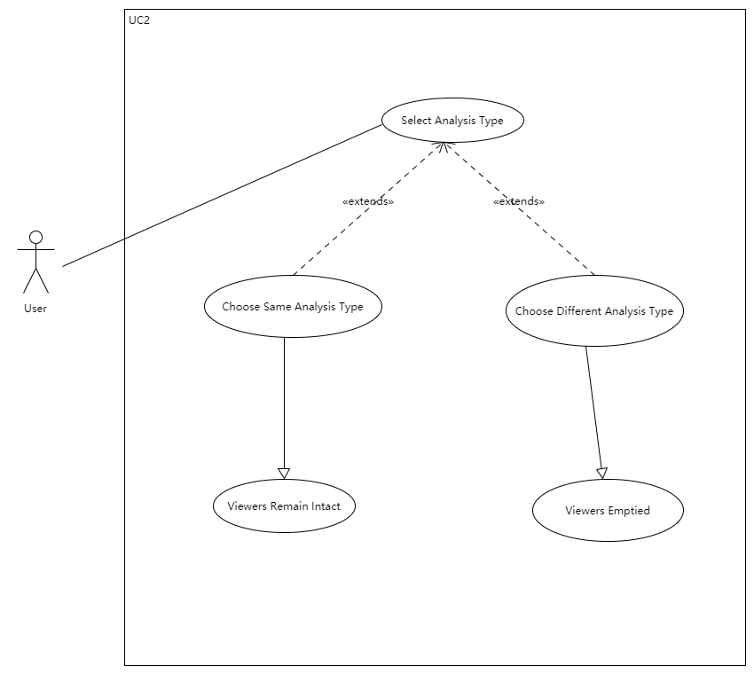

**UC3.**

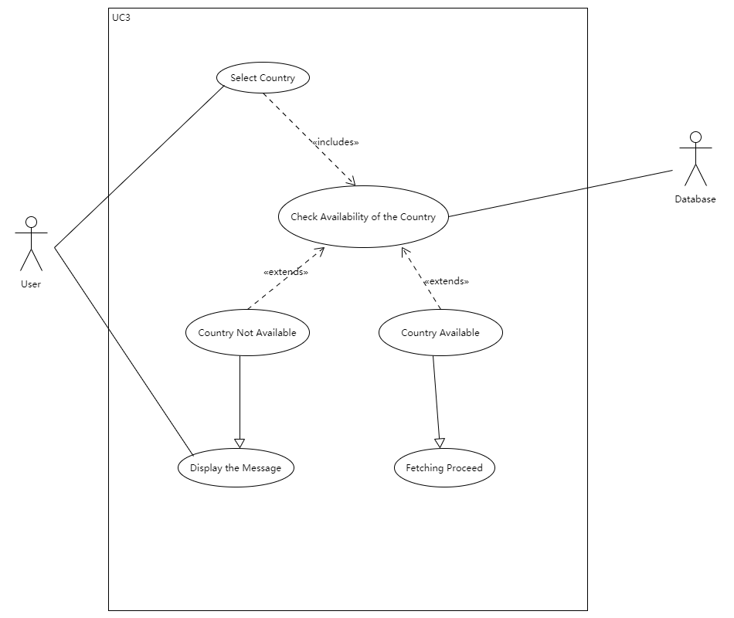

**UC4.**

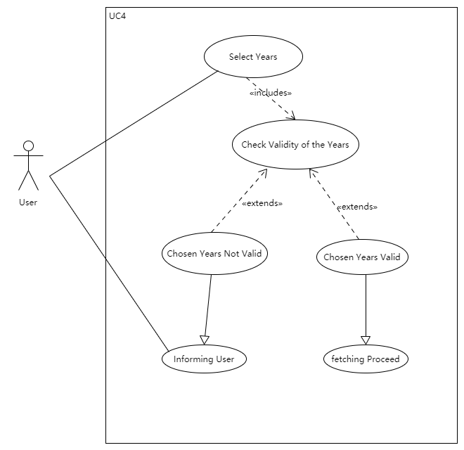

**UC5&6.**

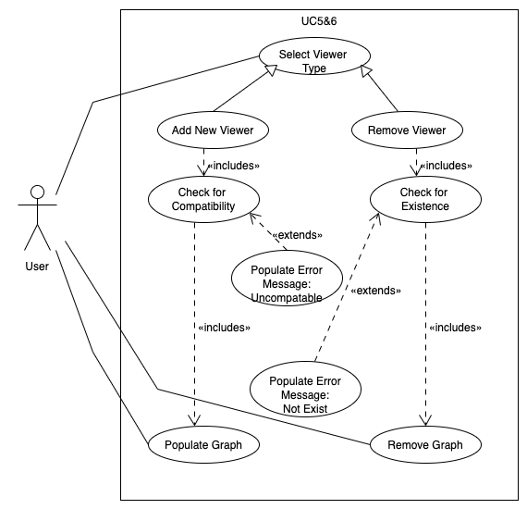

**UC7.**

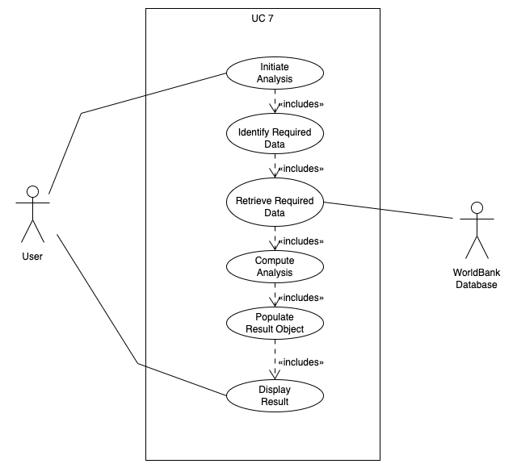

**UC8.**

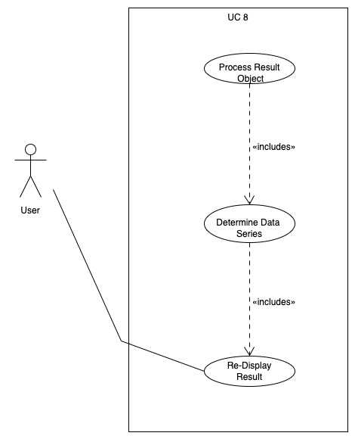

# Domain Model

## Domain Model Class Diagram

*The domain model class diagram for the Global Statistics Visualization Tool appears below:*

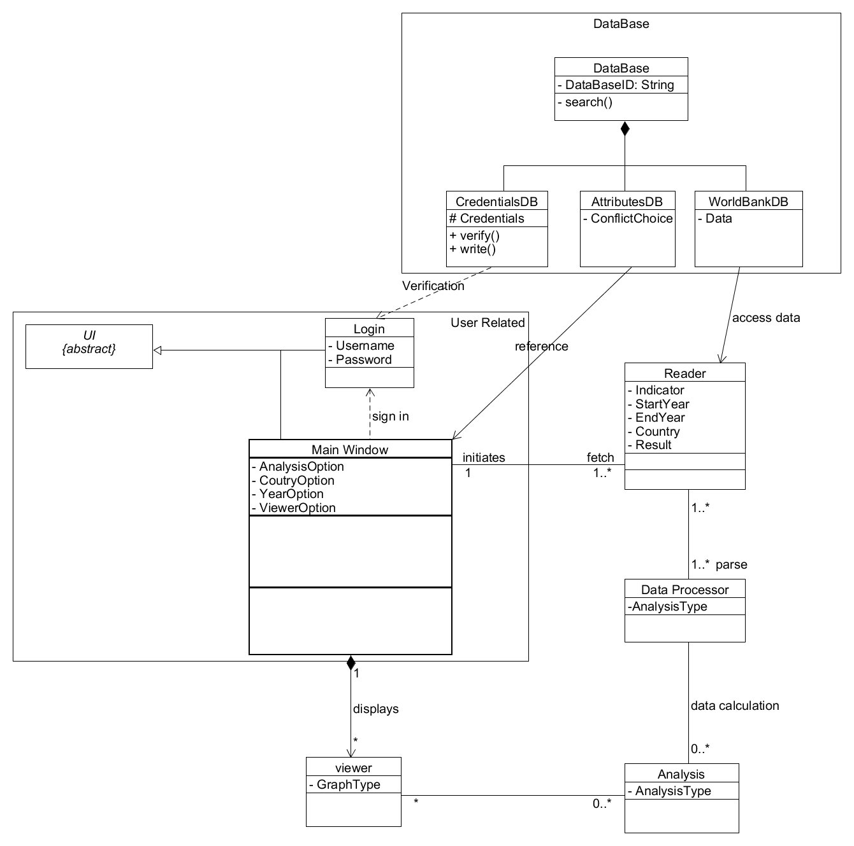

## Domain Model Class Definitions

### UI

|  |  |
| --- | --- |
| **Description** | This is an abstract class which would be inherited by the two panels that the user sees: the login panel and the main panel. It would only be a frame since the two panels have their own different functionalities. |
| **Attributes** |  |
| **Responsibilities** | The UI class should be declared as abstract with minimum configuration to create the window, and let its child class do the modification. |
| **Business Rules** |  |

### Login

|  |  |
| --- | --- |
| **Description** | This object inherits from UI and is used to log in to the main program. It is the first user interface that’s been displayed to the user, it checks username and password provided by the user and proceeds to the main panel if correct. This object is the dependency in the relation. |
| **Attributes** | - Username  - Password |
| **Responsibilities** | This object is responsible for providing blanks and a button to login, once the user puts username and password it is supposed to check for the record in the database, if such combination exists the user should be granted access to the main window, and terminates otherwise. |
| **Business Rules** |  |

### Main Window

|  |  |
| --- | --- |
| **Description** | This class inherits from UI and is the main part of the software that’s shown to the user, it shows various features of the software such as the data visualization or the viewers, the user can also choose a range of data and graphs to be displayed. |
| **Attributes** | - AnalysisOption  - CountryOption  - YearOption  - ViewerOption |
| **Responsibilities** | This object should act as a hub through the reader class to viewer class, it is responsible to provide the options that user chooses for the reader class to fetch for required data, and after the data has been processed and presented into various graphs that user wants, the main window is supposed to collect the viewer objects and display them inside the panel. |
| **Business Rules** |  |

### Reader

|  |  |
| --- | --- |
| **Description** | This class is essentially a tool to fetch data from the desired website, it receives information about the wanted data, and then visits the website to collect necessary data to send to the processor class for further use. |
| **Attributes** | - Indicator  - StartYear  - EndYear  - Country  - Result |
| **Responsibilities** | Objects of this class are responsible to identify the location of required data and collect it from the website, all of the data is then sent to the Data Processor for further use. |
| **Business Rules** |  |

### Data Processor

|  |  |
| --- | --- |
| **Description** | This class represents the role of translating raw data from the website to a simpler and more precise form that is more efficient to use for analysis. |
| **Attributes** | - AnalysisType |
| **Responsibilities** | This class is responsible to parse any raw data of the format on the website to better cooperate with the analysis class. |
| **Business Rules** |  |

### Analysis

|  |  |
| --- | --- |
| **Description** | Perform calculations if need for the analysis type and integrate the data together for the viewer class to generate graphs |
| **Attributes** | - AnalysisType |
| **Responsibilities** | Perform calculations if need for the analysis type and integrate the data together for the viewer class to generate graphs |
| **Business Rules** |  |

### Viewer

|  |  |
| --- | --- |
| **Description** | This is a class to present the data using graphs of the user's choice. |
| **Attributes** | -GraphType |
| **Responsibilities** | Responsible for building different types of graphs with certain data, and forward the graphs to the main window for display. |
| **Business Rules** |  |

### DataBase

|  |  |
| --- | --- |
| **Description** | This is a father class of the three database classes. |
| **Attributes** | -DataBaseID |
| **Responsibilities** | The databases store data necessary for the system to work.  The credential database contains all the username and password pairs recorded in the system and can be accessed to verify user login, it is also able to write new pairs inside.  The Attributes database is used for storing any conflict choices of the country and year selection.  The world bank database is a reference to the actual world bank database, it stores the data fetched from the official website. |
| **Business Rules** |  |

# Sequence and Activity Diagrams

## Sequencing Diagrams

UC1.

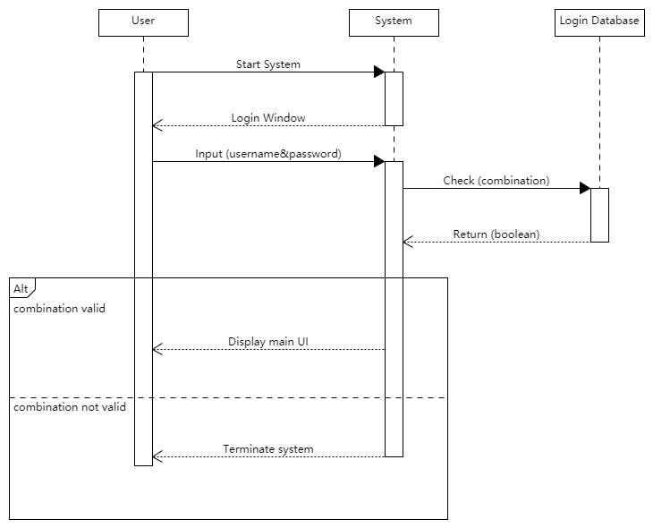

UC2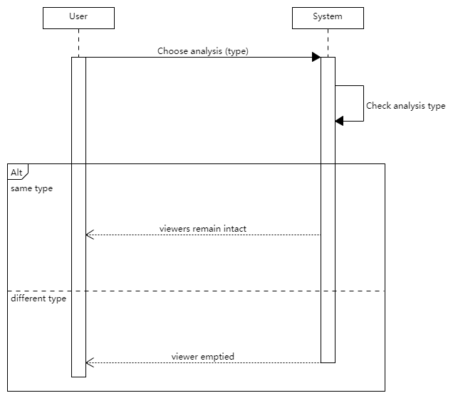

UC3.

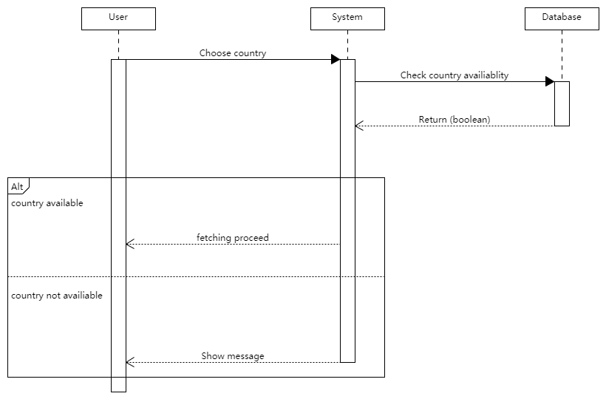

UC4.

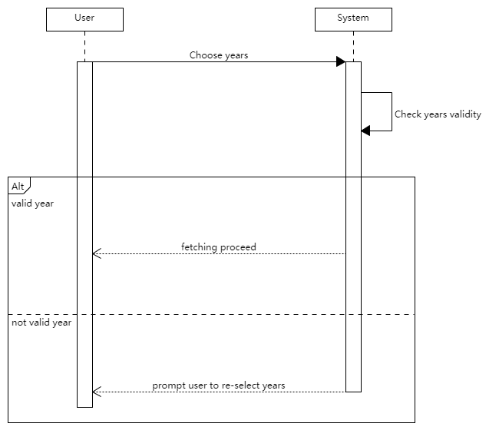

UC5.

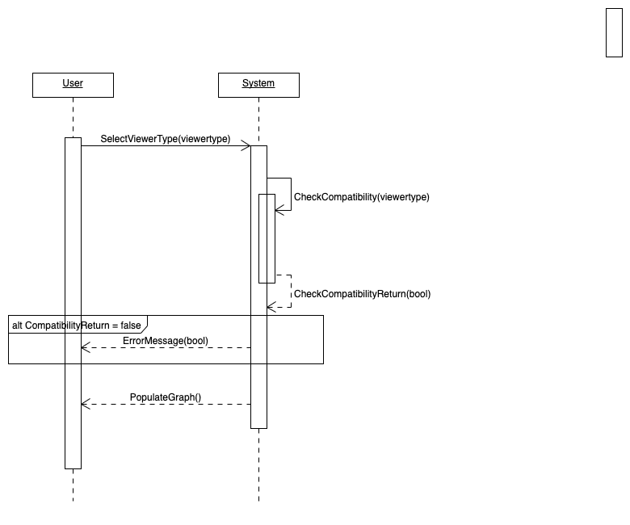

UC6.

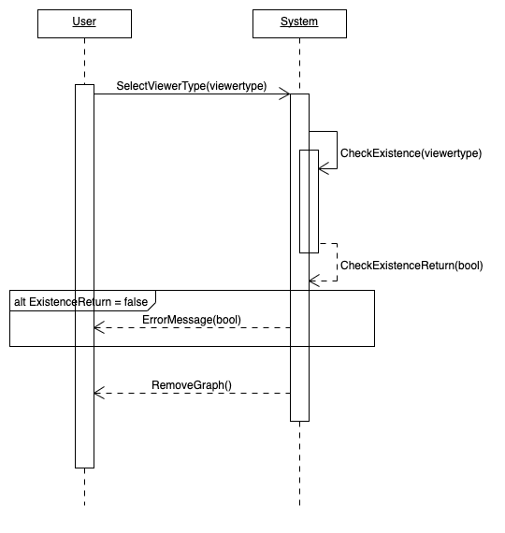

UC7.

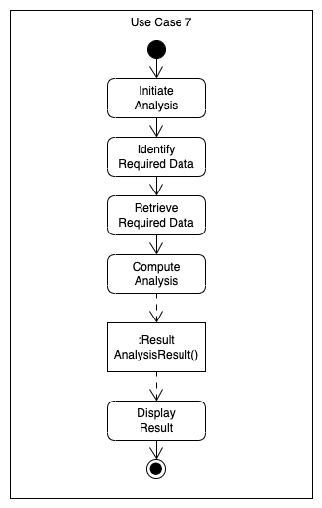

UC8.

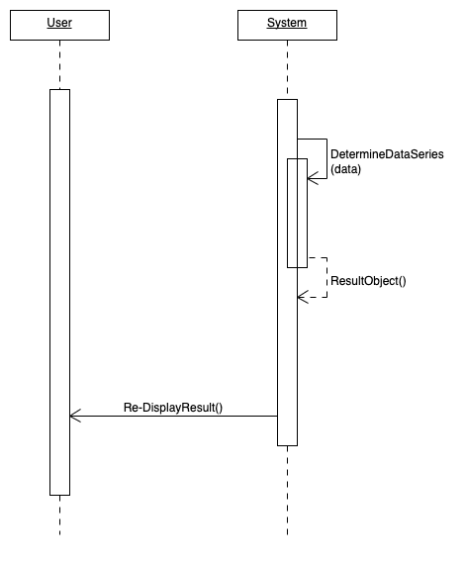

## Activity Diagrams

### UC1.

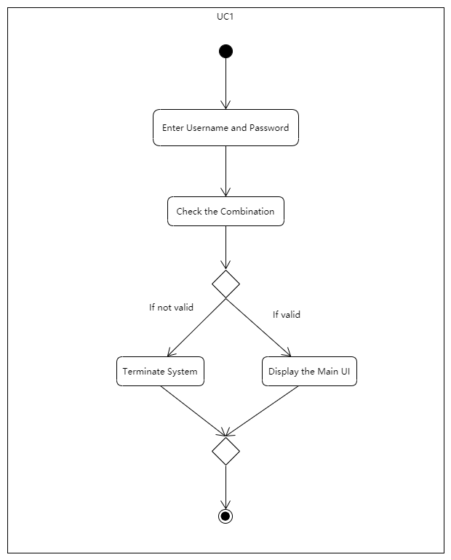

### UC2.

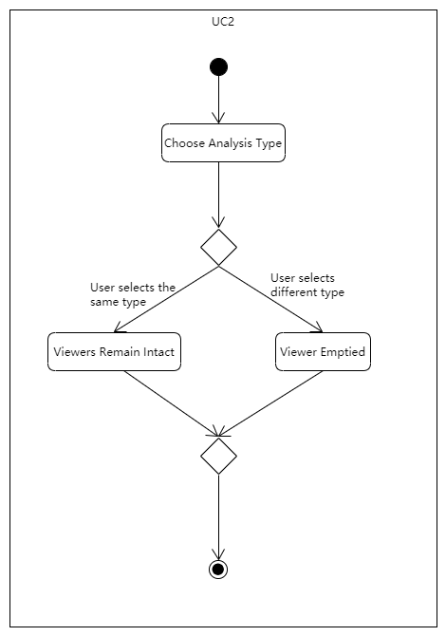

### UC3.

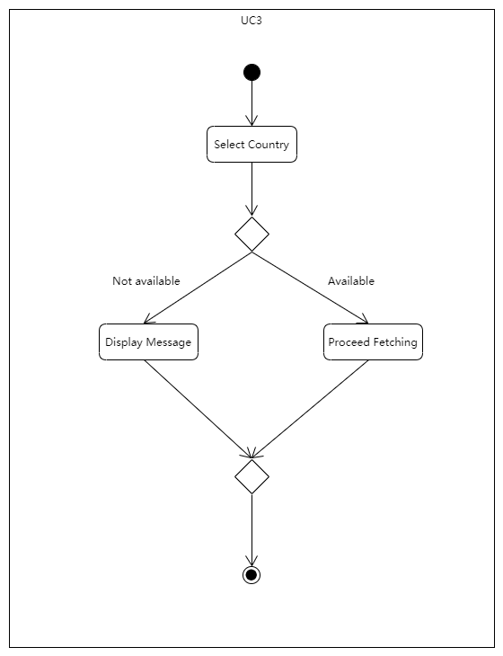

### UC4.

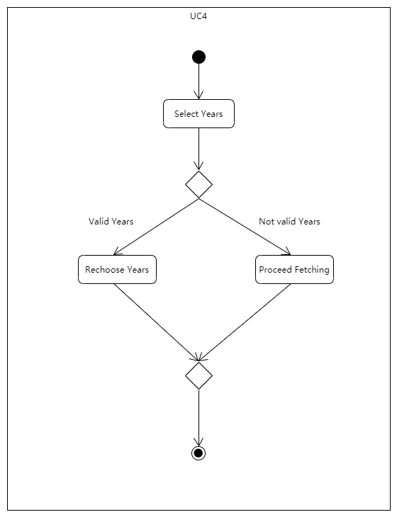

### UC5.

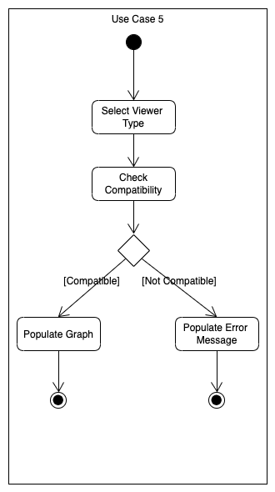

### UC6.

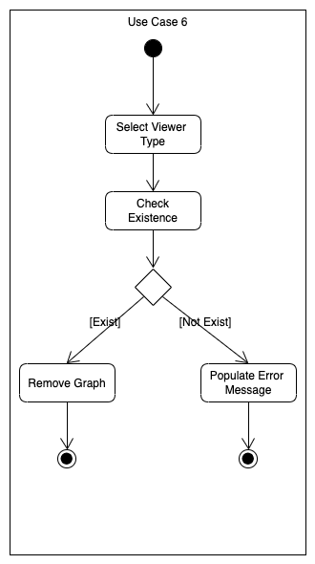

### UC7.



### UC8.

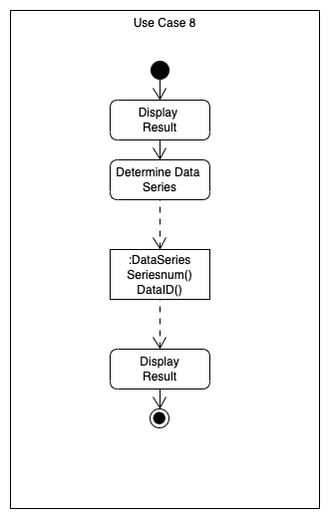

# Non-Functional Requirements Specification

## Overview

The non-functional requirements of the system are composed of utilities, environments and other specifications that are necessary for the smooth operation of the system as a whole. This includes interfaces, development environment, capacity specifications, network and operational parameters.

## Enabling Technologies

### Target Development Environment

The system should be developed in a Windows environment and using Java. Eclipse will be the Integrated Development Environment (IDE) used for coding purposes.

### System Interfaces

Due to deployment requirements, specific system interfaces may be required (eg. to use the json to get the data from the database). Focus on the enabling technology aspect of these connections.

Where specific technology must be used, document the requirements.

The account should list each system interface and identify the functionality of the software to accomplish the system requirement and the interface description to match the system.

## Capacity Planning

### Permanent Storage

In order to be reliable, the system will use two disks. This ensures that if one of the disks fails the other disk functions as a single hard drive until the faulty one is replaced. For system installation, activity logging, and user login information, the disk size used will be 30 GB. Most of that space would be occupied by data and login information such as the user's username and password, data extracted from the world bank database.

## Network

The system should have connectivity to the Internet with bandwidth sufficient enough to carry data from the world bank. To make sure every request could get the data as soon as possible.

## Workstations

*The minimum system requirements and configurations for the computers used for the development, deployment and execution of the system are:*

A hard disk space of 3GB to install Windows and a Java Virtual Machine. A processor speed of 300 MHz and a memory of 64 MB is sufficient. A display setting of 1024 x 768 resolution and a 16-bit color palette should be used. The workstation should also include enough memory to store the data and could run the analysis algorithm.

## Operational Parameters

### Useability

The users could easily login into this system. and the system should be learnable and usable by the average computer user who has exposure to analysis software. The UI will be designed in such a way that the buttons are conspicuous and meaningful making it easy to access all the functions of the system, every data summary and visualization graphs are readable.

### Reliability

To make sure the system could always access the database, and the system should always be available to the user. The backup and recovery functions of the system will consist of a data analysis algorithm which will be taken at regular intervals and stored somewhere external to the system. The Mean Time To Repair should be minimized which will in turn minimize Mean Time Between Failures.

### Maintainability

To make sure that every result of the analysis is correct and try to test every combination of functions.

### 

# Activities Plan

## Gantt Chart

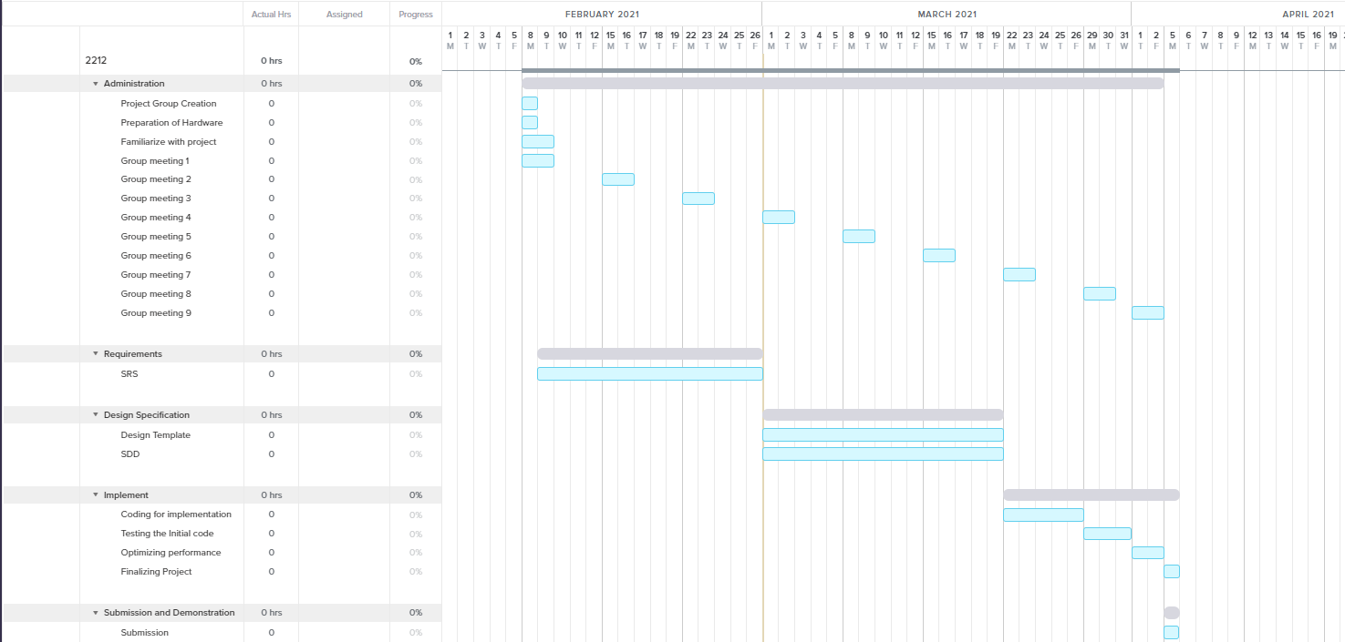

## Project Backlog and Sprint Backlog

*Project Backlog*

|  |  |  |  |
| --- | --- | --- | --- |
| *Backlog item* | *Priority* | *Status* | *Estimate (hrs)* |
| *User Interface (Login and Main window)* | *High* | *To be started* | *10* |
| *The reader class* | *High* | *To be started* | *10* |
| *Data processor class + Analysis class* | *High* | *To be started* | *10* |
| *Viewer class* | *High* | *To be started* | *10* |

## Group Meeting Logs

|  |  |  |
| --- | --- | --- |
| **Present Group Members** | **Meeting Date** | **Issues Discussed / Resolved** |
| Yumeng Chen, Zhen Yang, Ziqin Shang,Yifei Zhang | 2021/02/07 | Discussion of general project information and scope of project。 |
| Yumeng Chen, Zhen Yang, Ziqin Shang,Yifei Zhang | 2021/02/08 | Distribution of tasks |
| Yumeng Chen, Zhen Yang, Ziqin Shang,Yifei Zhang | 2021/02/13 | Completion of Deliverable 1, merging of individual tasks |
| Yumeng Chen, Zhen Yang, Ziqin Shang,Yifei Zhang | 2021/02/15 | Distribution of tasks |
| Yumeng Chen, Zhen Yang, Ziqin Shang,Yifei Zhang | 2021/02/22 | Discuss the problems |
| Yumeng Chen, Zhen Yang, Ziqin Shang,Yifei Zhang | 2021/03/01 | Completion of Deliverable 2, merging of individual tasks |

# Test Driven Development

|  |  |
| --- | --- |
| **Test ID** | 1 |
| **Category** | The log-in function of the system implemented to verify through credential DB and the ability to present the user the main window and handle exceptions. |
| **Requirements Coverage** | UC1-User log in |
| **Initial Condition** | The database contains some credential pairs enough for the test, the system has been initialized and ready for input. |
| **Procedure** | 1. The user opens the program.  2. The user input usernames and passwords, correct and wrong pairs should be provided to test the full functionality.  3. The user logs into the system successfully and the program now presents the main window.  4. If the user has entered the wrong username or password, the program should be able to request them again or terminate with a button. |
| **Expected Outcome** | 1. The credentials matched with the one in the DB and main windows should be presented with the login panel closed after verification.  2. If the credentials don’t match, the program should inform the user and prompt for input again. |
| **Notes** | With some restriction in choosing username and password (e.g., no special characters), the program should be able to handle any combination that is permitted. |

|  |  |
| --- | --- |
| **Test ID** | 2 |
| **Category** | The functionality of the main window UI |
| **Requirements Coverage** | UC2, UC3, UC4, UC5, UC6  In this test only the functions of the main window UI specified in these use cases will be the main concern. |
| **Initial Condition** | The user had successfully logged in, and the main window now initialized. |
| **Procedure** | 1. Once the main window is presented, test all the functions within the interface (i.e., Ability to select analysis types; countries; years, and to add or remove graph types to be displayed)  2. The test should be looking for any formatting, menu, composition errors and mistakes that might occur to the main window. |
| **Expected Outcome** | The selection and add or remove graphs function should work properly, the size of the window and font should be appropriate. |
| **Notes** | It might be better to prepare some data manually from the world bank website to test some functions such as selection range and the ability to process the data in the raw format. |

|  |  |
| --- | --- |
| **Test ID** | 3 |
| **Category** | The evaluation of backstage processes and the cooperation between such functions with the main window UI. |
| **Requirements Coverage** | UC7-Performing analysis, UC8-Displaying the results |
| **Initial Condition** | The user had done the selections and chosen the graph types to be displayed, and clicked the recalculate button. |
| **Procedure** | The list of steps required for this test case (*e.g.*  1. The user made selections and clicked the recalculate button.  2. The reader class now visits the world bank and fetches the required data that correspond to user’s selection.  3. The data is processed into better format and sent for analysis for further process and calculation depending on the user's choice.  4. Once the analysis is done, it should be used to generate graphs that the user chose, the graphs are then returned to the main window along with the text-based analysis to be displayed. |
| **Expected Outcome** | The graphs of chosen analysis types and options should be displayed properly, the program should be ready for another round of analysis. |
| **Notes** | The test should be performed multiple times with different combinations of selection to ensure the full functionality of the program in all aspects. |

# Domain Dictionary (optional and as required)

## Terms and Abbreviations